**New Milford Board of Education**

**Facilities Sub-Committee Meeting Minutes  
May 13, 2025 6:30pm**

**Sarah Noble Intermediate School Library Media Center**

| Present: | Mr. Tom O’Brien, Chairperson  Mr. Eric Hansell  Mrs. Wendy Faulenbach  Mr. Brian McCauley |
| --- | --- |

| Absent: |  |
| --- | --- |

| Also Present: | Dr. Janet Parlato, Superintendent of Schools  Ms. Holly Hollander, Assistant Superintendent  Mr. Matthew Cunningham, Director of Facilities  Mr. Anthony Giovannone, Director of Finance  Mr. Jeffrey Turner, Technology Director |
| --- | --- |

| **1.** |  | **Call to Order**  The New Milford Board of Education Facilities Sub-Committee meeting was called to order at 6:30pm by Mr. Tom O’Brien, Chairperson. | **Call to Order** |
| --- | --- | --- | --- |
| **2.** |  | **Public Comment**  There was none. | **Public Comment** |
| **3.** | **A.**  **B.**  **C.**  **D.**  **E.                                        F.** | **Items for Information   New Milford High School Gutters**  Mr. Cunningham stated facilities met with the contractor on-site to review the gutter repairs. An agreement is being finalized for the seams to be patched this summer. Work should happen once school is out for the summer and done before the start of the school season. There are 152 gutter seams to repair. Mrs. Faulenbach asked if there was a lifespan on the repair work. Mr. Cunningham stated these are sectional gutters that were installed in 2000. Some of the seams are still water-tight and some are not. It could be years before there is concern about the repairs.  **Hill & Plain School Canopy** Mr. Cunningham stated facilities met with the contractor on-site to review the canopy repairs. An agreement is being finalized for the roofs to be replaced this summer. The project will start June 16th and, with weather permitting, will be a week long project.  **Schaghticoke Middle School Underground Storage Tank** Mr. Cunningham stated Weston & Sampson has developed the scope for the eventual replacement of the underground storage tank at Schaghticoke Middle School. This bid package is being reviewed by the District’s Attorney and the bid is expected to be posted on May 16, 2025. Mr. O’Brien asked about the funding source. Mr. Cunningham stated it has already been encumbered. Mrs. Faulenbach asked which projects were earmarked for Capital Reserve. Mr. Cunningham stated all of the three projects listed above were earmarked for Capital Reserve.  **Sarah Noble HVAC** Mr. Cunningham stated over the April break the maintenance team repaired over 60 dielectric pipe unions associated with the HVAC equipment at Sarah Noble Intermediate School. Mr. Cunningham stated he believes this extensive work addressed the leaks and dampness that occurs during the cooling season. If the project had been outsourced it would have been a cost to the district of $30,000-$50,000. Facilities was methodical in their approach and were able to complete the project in 4 days.  Mr. O’Brien stated that the board assumed it would be a large expense just to figure out what was causing the issue, let alone the cost to fix it. It was wonderful it was done by our team. Mrs. Faulenbach praised the work and asked if there was ever a concern that that moisture created issues within the building. Mr. Cunningham stated that facilities got rid of anything that could retain moisture, including ceiling tiles and insulation. Mrs. Faulbenbach asked if there was any overtime associated with the project. Mr. Cunningham stated not during spring break, but perhaps a few Saturdays leading up to it. It was easier to come into the building on a weekend when there were no students so the whole building could be accessed and scope of work could be understood. Mr. Hansell asked if there was any indication the pipes were sacrificed or if it was just the union. Mr. Cunningham replied that the unions were the only pieces sacrificed.  Mrs. Faulenbach asked about the photos that O&G has on the project. Mr. Cunningham stated that O&G has to legally retain them, but only for another two years, and then they will pass them over to the district.  **New Milford High School Kitchen**  Dr. Parlato stated she has been exploring career pathways that will help better engage students. Dr. Parlato explained she is launching an initiative to begin to research a culinary program at the high school. It is still in its infancy but she is working hard to sketch out the program. This is a program that will teach a life skill to students and have a major impact on programming at the school.  Mr. Cunningham stated that they explored and will continue to explore other culinary programs at nearby high schools to see what a contemporary culinary arts program looks like. This helped them to understand expectations as well as necessary equipment such as fire compressions and ductwork. They are now looking to see where it could be set up at New Milford High School. Mr. O’Brien asked if the high school ever had a culinary program. Mr. Cunningham stated nothing at the high school was built that would lend itself to a kitchen.  Mrs. Faulenbach asked if there was a time frame. Dr. Parlato stated there was not, they are still looking at what other schools are doing and trying to figure out the space. One of the positives of a culinary program is that the curriculum is not difficult to build out. Mr. Hansell asked if a new ventilation system would be necessary. Mr. Cunningham stated yes, it would have to have its own ventilation system, separate to the cafeteria. It’s about seeing where it would be easiest to have the electricity, equipment and instructional space.  Dr. Parlato stated this program is life changing for kids. Culinary programs have students learn sales, marketing, chemistry and more.  **Central Office** Mr. Cunningham stated he had a meeting with an architect today to discuss a permanent private office space. Overall, once requirements are looked into, there can then be conceptual drawings that can be brought before the board.  Dr. Parlato stated she agreed with the need for confidential space and hopes to use the small amount of move money left to update the current space.  Mrs. Faulenbach stated confidentiality is important in a school district and it’s frustrating to feel we’ve been left behind. It’s on the board to make this happen and it’s worth approaching the town for help. These are town buildings. Any and all options have been looked into. Confidentiality, safety, and other factors need a short and long term commitment.  Mr. Cunningham stated, once the walls are put up for privacy, HVAC and lighting will have to be reconstructed. That is the most expensive piece since it will require putting in splits. Mr. O’Brien asked if this will require design work. Mr. Cunningham stated, to do it properly will require drawings and permits. The staff has worked through it but they need office space. This is the most efficient means of getting professional office space done. Mr. O’Brien asked if some of the work could be done over the summer. Mr. Cunningham stated that there would be an order of operations to follow. Since there is not any demo happening it could even be done during the school year.  Mrs. Faulenbach stated that there is a need for offices that befit the responsibility of our staff and have space that works. Mr. Cunningham stated the next step is to talk to a few more firms, then speak to them about having an architect come in. This is the only path we can take to have professional work spaces. Mr. O’Brien asked if there is enough money left over from the move to fund the project. Mr. Giovannone stated there is $8,921 left. Mrs. Faulenbach stated the recommendation of the funding source is to do it by the book. This approach is much less than the cost of a new building. It should come from capital reserve and the district can ask the town to help. | **3. Items for Information**   1. **New Milford High School Gutters** 2. **Hill & Plain School Canopy** 3. **Schaghticoke Middle School Underground Storage Tank** 4. **Sarah Noble HVAC** 5. **New Milford High School Kitchen** 6. **Central Office** |
| **4.** |  | **Public Comment**  None | **Public Comment** |
| **5.** |  | **Adjourn**  *Mrs. Faulenbach moved to adjourn the meeting at 7:10 pm, seconded by Mr. Hansell and passed unanimously.* | **Adjourn**  *Motion made and passed unanimously to adjourn the meeting at 7:10 pm.* |

Respectfully submitted:

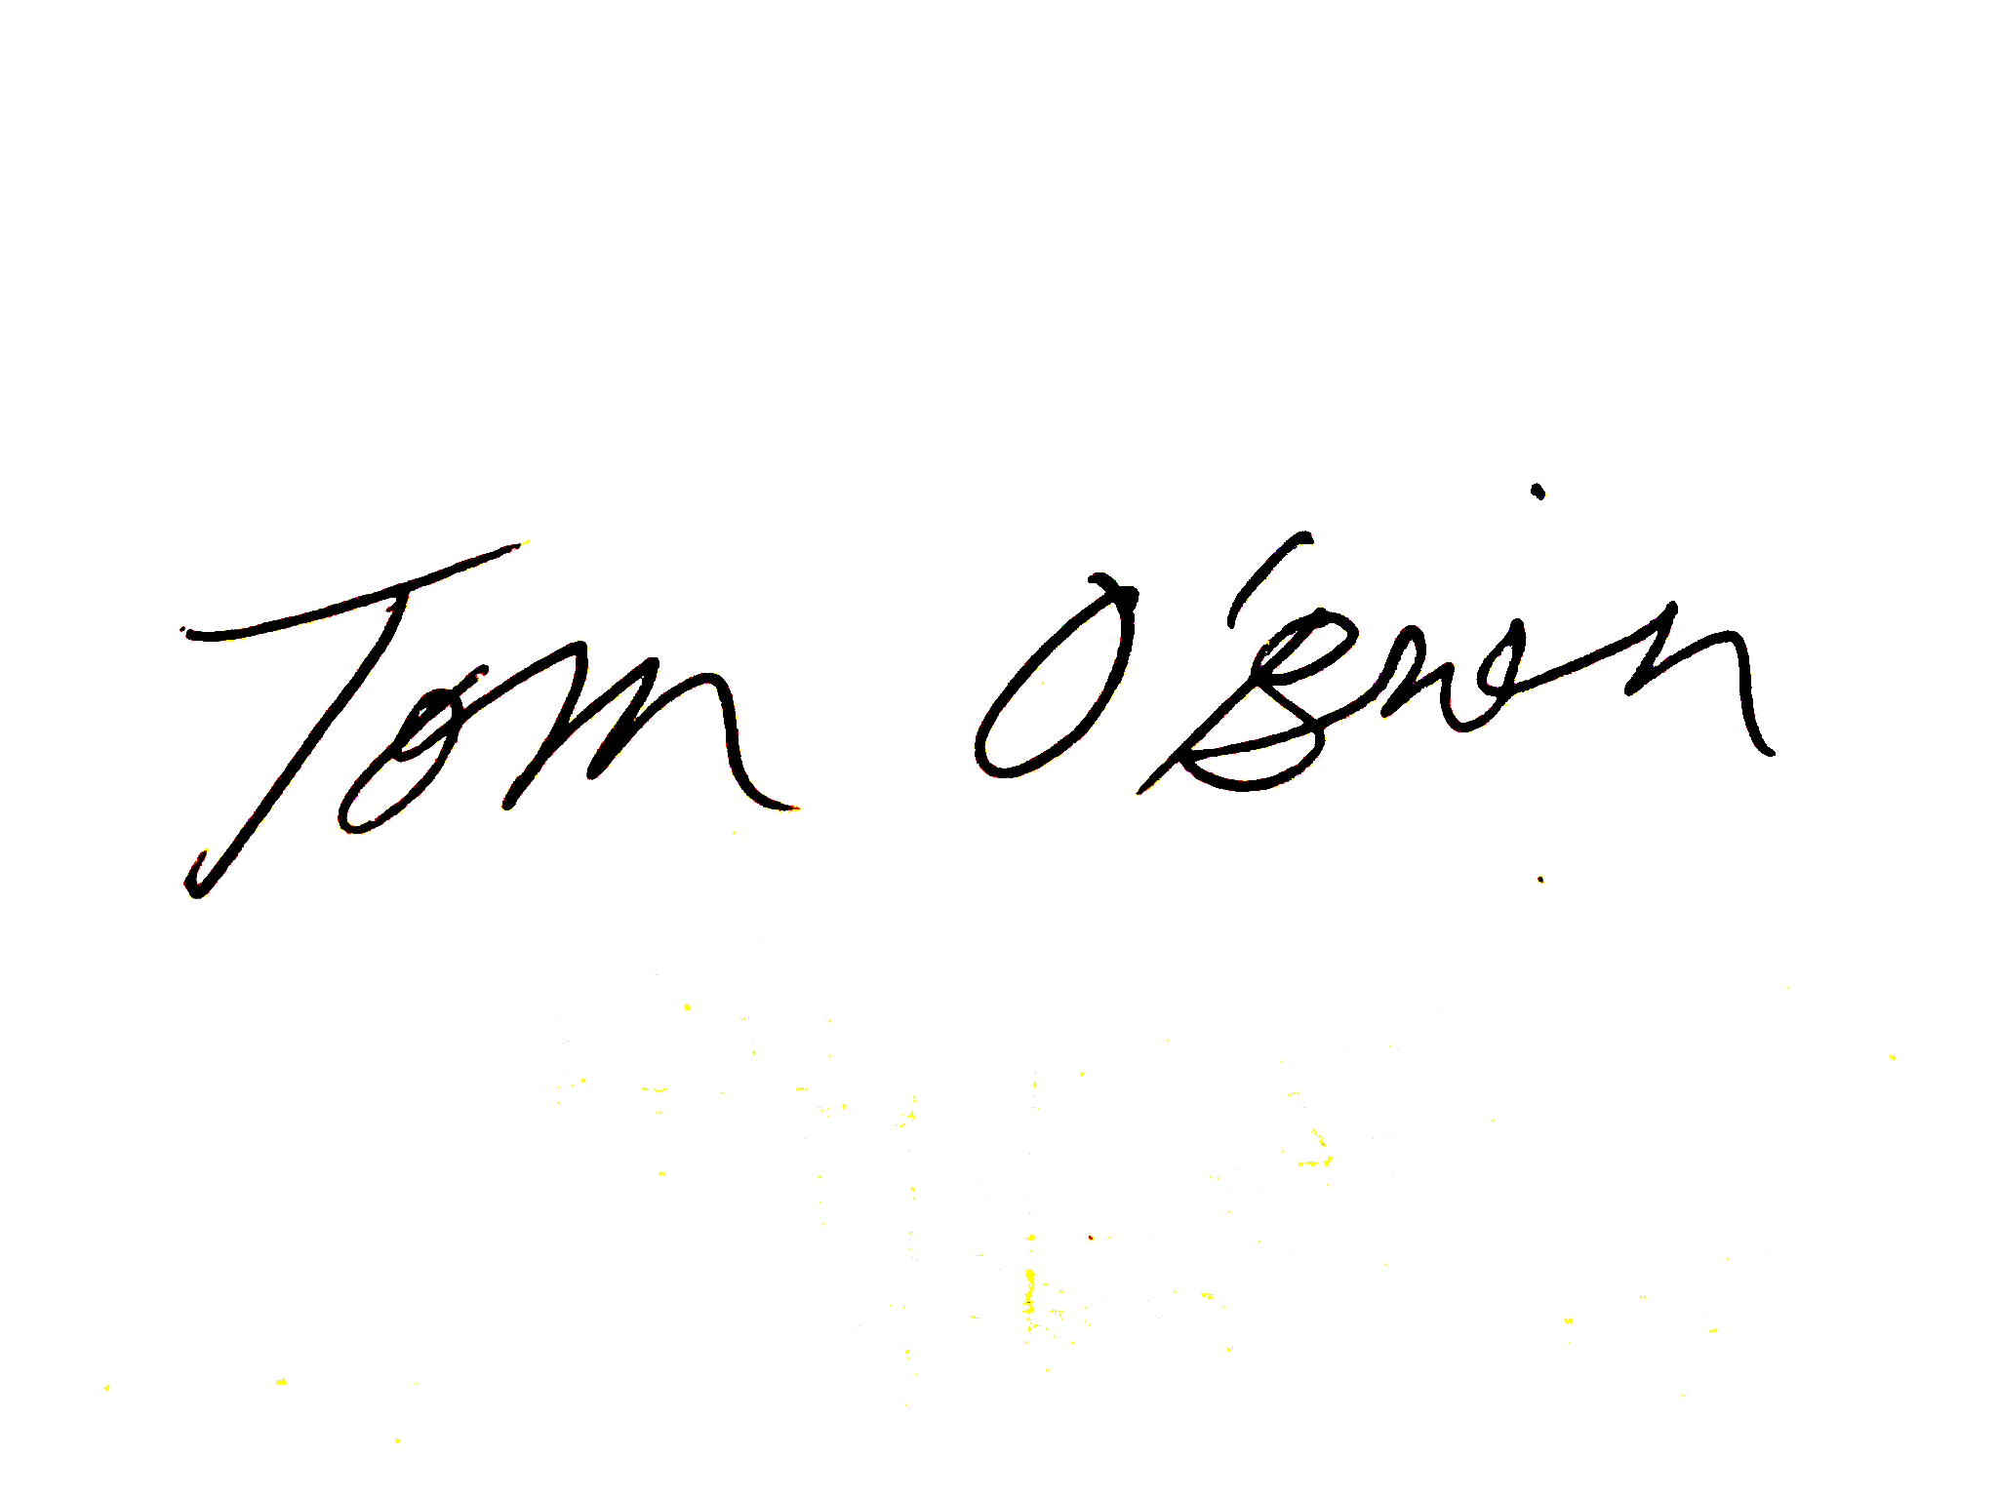

Tom O’Brien

Chairman, Facilities Subcommittee