denc

| Present: | Mrs. Leslie Sarich  Mrs. Tammy McInerney  Mr. Dean Barile |
| --- | --- |
| Absent: |  |

| Also Present: | Dr. Janet Parlato, Superintendent of Schools  Ms. Holly Hollander, Assistant Superintendent |
| --- | --- |

| **1.** |  | **Call to Order**  The New Milford Board of Education Policy Sub-Committee was called to order at 6:45 pm by Mrs. Leslie Sarich. | **Call to Order** |
| --- | --- | --- | --- |
| **2**. |  | **Public Comment**  None | **Public Comment**  None |
| **3.** | **A.**  **B.** | **Discussion and Possible Action**  **Policies for Initial Review and Approval on First Read**   1. 4118.113 Policy Regarding Prohibition  of Sex Discrimination,  Including Sex-Based   4218.113 Harassment (Personnel)   1. 5145.7 Policy Regarding Prohibition  of Sex Discrimination,  Including Sex-Based  Harassment (Students)   Dr. Parlato stated she wanted to start the school year with the most updated Title IX policy. Mrs. McInerney asked if it was mandated. Dr. Parlato stated yes, it is federally mandated. Mrs. McInerney noted the same policy is listed online with two different numbers and asked if one could be deleted.  *Mrs. McInerney moved to bring the policies as listed on the agenda, in 3.A, to the full board for Initial Review and Approval on First Read. Seconded by Mr. Barile.*  **Items of Information**   1. **4118.113 R Administrative  Regulations Regarding Prohibition of Sex  Discrimination,**   **4218.113 R Including Sex-Based  Harassment (Personnel)**   1. **5117 R Administrative  Regulations Regarding  School Attendance Areas** 2. **5145.7 Administrative  Regulations Regarding  Prohibition of Sex  Discrimination, Including  Sex-Based Harassment  (Students)**   **5117 R:**  Dr. Parlato stated 5117 R was brought back to the Policy Subcommittee to discuss the text in italics regarding the racial imbalance paragraph in this regulation. Mrs. McInerney asked if there was a policy for this. Dr. Parlato stated the policy is not required, and operationally, they wanted it still maintained as regulation. There was a question regarding the term “racial imbalance” in the full board meeting and was asked if it needs to be included in the regulation.  Mr. Barile asked what the numbers should be to be considered “racial imbalance.” If a parent wants to send their child to New Milford Public Schools (NMPS) they should be allowed to, regardless of the skin color. Dr. Parlato stated the imbalance percentage is directly stated in the law, and it must be followed. It is decided by grade band, so it only affects Northville Elementary School (NES) and Hill and Plain School (HPS), as these schools have the same grade bands. For example, if 1st grade at NES exceeds the percentage difference in students of color compared to HPS as prescribed by the racial imbalance law, then there would need to be a remedy to solve the imbalance. Dr. Parlato stated that if you are a resident of New Milford and you are a student, the school district cannot turn you away.  Mr. Barile asked how it is remedied. Dr. Parlato stated one example of a remedy is voluntary redistricting. Dr. Parlato stated that the district is not close to having a racial imbalance at this time.  Mrs. McInerney noted kids that want to enroll in NMPS, who are not residents, could be denied. Mr. Barile added that saying no to those kids because of the color of their skin is racial imbalance. It is wrong to tell a family they cannot come to the school because of the color of their skin.  Mrs. McInerney explained that there was a discussion of redistricting some years ago, but not for racial imbalance.  Mr. Barile stated he does not like the language surrounding the racial imbalance law, or the cost to redistrict, because of someone's color. Greenwich is currently faced with this problem of racial imbalance, and they are pushing back on the state. The state is forcing their hand and to him, it is a moral issue. Mrs. McInerney replied that not following the state guidelines could cause bigger problems. Dr. Parlato noted that following state law or not is a conversation the full board would have and vote on. Dr. Parlato asked Mr. Barile if he has reached out to New Milford’s state representatives.  Mr. Barile stated the racial imbalance law is a violation of the constitution. He is all for people coming to NMPS, but it is radical to look solely at someone's skin. He asked if the discretion is up to the Superintendent and Assistant Superintendent. Dr. Parlato replied, when you reach a certain percentage of grade band that is out of balance based upon students’ races, that is when the law is considered. It is not at the discretion of the Superintendent. Dr. Parlato explained how school placement for out of district students who might want to come here depends on how many spots are available in each grade. Mr. Barile stated he is not as worried about space since enrollment is going down.  Mrs. McInerney stated she is worried. There are apartments going up in town and believes we are closer to redistricting than people might think. Dr. Parlato stated they will be doing an enrollment study in the next 18 months, and it will help understand how it will affect enrollment.  Mr. Barile noted he has made his position clear. If it doesn’t need to be regulation, and is not a policy, he would rather not have it as regulation.  Dr. Parlato stated the regulation can be maintained without the racial imbalance language, but she must follow the law to maintain her administrative license even if that language is not present in the regulation. The board, as an acting body, would figure out how to remedy it if there was ever an imbalance concern.  Mrs. Sarich stated, even if the section is taken out, if the numbers trigger it, we still have to follow it.  Mr. Barile put on the record that he is not endorsing it.  Mrs. McInerney stated she does not see it as an endorsement, and perhaps leaving it in would give people more awareness of it and an opportunity to say something based upon this regulation.  Dr. Parlato explained that this regulation will be on the next full Board agenda for further discussion. | **3. Discussion and Possible Action**   1. **Policies for Initial Review and Approval on First Read** 2. **4118.113 Policy Regarding Prohibition of Sex Discrimination, Including Sex-Based**   **4218.113 Harassment (Personnel)**   1. **5145.7 Policy Regarding Prohibition of Sex Discrimination, Including Sex-Based Harassment (Students)**   Motion made and passed unanimously to bring the policies as listed in 3.A to the full board for initial review and approval on First Read.  **B. Items of Information**   1. **4118.113 R Administrative Regulations Regarding Prohibition of Sex Discrimination,**   **4218.113 R Including Sex-Based Harassment (Personnel)**   1. **5117 R Administrative Regulations Regarding School Attendance Areas** 2. **5145.7 Administrative Regulations Regarding Prohibition of Sex Discrimination, Including Sex-Based Harassment (Students)** |

| **5.** |  | **Public Comment**  None | **Public Comment** |
| --- | --- | --- | --- |
| **6.** |  | **Adjourn**  *Mrs. McInerney moved to adjourn the meeting at 7:19 pm, seconded by Mr. Barile and passed unanimously.* | **Adjourn**  Motion made and passed unanimously to adjourn the meeting at 7:19 pm. |

Respectfully submitted:

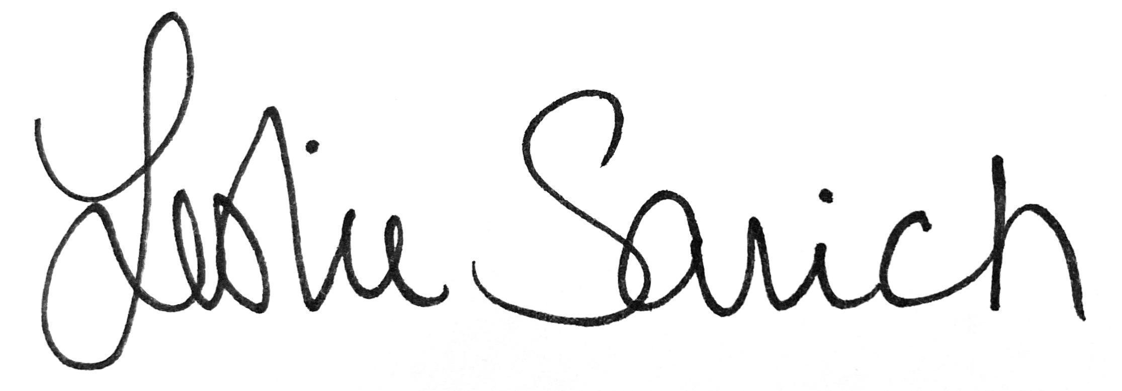

Mrs. Leslie Sarich

Chairman, Operations Subcommittee